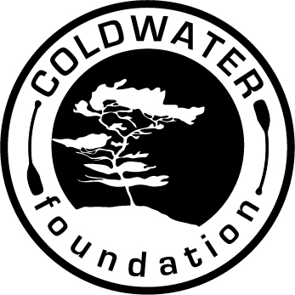

Acknowledgement of Risk
Assumption of Personal Responsibility
Waiver and Release of Liability

I have chosen to voluntarily participate in the COLDWATER wilderness program. I have read a description of the nature of this rigorous experience. In consideration for the educational benefits and/or privileges associated with my participation in this program I acknowledge and agree to be bound by the following:

1. Identification of Risks
I understand that the COLDWATER Wilderness program will be conducted almost exclusively in an isolated outdoor environment. It will operate in all kinds of weather, in a wide variety of physical settings, and with diverse people. As a result, I further understand that during my participation I may be exposed to unusual risks and stresses which may result in property damage or severe, maybe even fatal, injury. These include but are not limited to the hazards of traveling over rugged terrain or deep water, high and low challenge course experiences, rock climbing and rapelling/descending, broomball, hockey, ice skating, snowshoeing, skiing, riding bikes, building fires, using knives, and having injuries or illnesses in remote areas without medical facilities. Forces of nature such as darkness, heavy rain, lightening, ice and snow, strong winds, extremes of heat and cold, biting insects and animals, fast water, and falling objects may independently or in combination with my activities cause a serious accident. Stresses may also result from emotional anxiety, interpersonal conflicts, homesickness, and irregularities in eating, sleeping and bathing.

2. Acknowledgement of Risk
I understand COLDWATER to be a challenging experience conducted in an isolated wilderness environment. I understand that although COLDWATER FOUNDATION has taken reasonable precautions to provide proper equipment, suitable facilities and qualified instructors, it is impossible to guarantee absolute safety against illness, injury or loss resulting from my participation. I acknowledge the risk inherent in wilderness activities and agree to assume that risk.

3. Assumption of Personal Responsibility
I agree that I am responsible for my safety while participating in this COLDWATER program and I am willing to assume that responsibility. This means that I agree to follow any instructions and directions given me by the COLDWATER staff, and will seek to act carefully and with good judgment at all times. I also agree to verify with my physician that I have no physical or psychological problems that would prohibit or limit my full involvement. I will submit current health information to the COLDWATER staff, in writing, for any medical or emotional condition which may restrict my safe participation in the program.

4. Waiver and Release
In light of the above, I waive, release and hold harmless any and all claims for damages of death, personal injury, or property loss which I may have as a result of my participation in this program. I understand that these injuries and losses might result from the actions, inactions or carelessness of other participants as well as from my own actions. More specifically, I hereby hold Coldwater Foundation for Leadership and Community Development or any individual acting in an official or advisory capacity for Coldwater Foundation, harmless and release Coldwater Foundation and its agents from any liability and claims arising out of an accident or stressful incident during the program, except where caused by the gross negligence or wanton misconduct of any of the released parties. I intend this waiver and release to also apply to any relatives, heirs, next of kin, personal representatives, or assigns who might pursue any legal action or claim on my behalf.

5. Insurance
I currently have, and agree to maintain throughout my participation, valid and sufficient medical and accident insurance. I understand that this is my sole responsibility and release all persons and entities from providing this coverage for me.

6. Refund
I understand that in case of voluntary withdrawal from the program after it has begun, I will not receive a refund. (A refund of 25% will be granted to a participant who must leave during the first half of the course due to uncontrollable circumstances.)

Name (please print) Age ________Birthdate

Signature Date
_ _ _ _ _ _ _ _ _ _ _ _ _

SIGNATURE OF PARENT OR GUARDIAN IS REQUIRED FOR ALL UNDER 18 YEARS OLD.

Parent /Guardian (Print Name) ___________________________________ Relationship___________________________

Parent /Guardian Signature ______________________________________ Date ______________________

